

PERSONAL DATA
INFORMATION SYSTEM

MINI PROJECT REPORT

Submitted by

BHUVANA S (20BAD004)

KARTHIKA APS (20BAD010)

VIJAYABARATHI V (20BAD020)

SAFHRIN A (20BADL02)

in

19AD351 – PYTHON PROGRAMMING LABORATORY

DEPARTMENT OF ARTIFICIAL INTELLIGENCE AND DATA SCIENCE

MEPCO SCHLENK ENGINEERING COLLEGE

SIVAKASI

DECEMBER 2021

MEPCO SCHLENK ENGINEERING COLLEGE, SIVAKASI
AUTONOMOUS
DEPARTMENT OF ARTIFICIAL INTELLIGENCE AND DATA SCIENCE

BONAFIDE CERTIFICATE

This is to certify that it is the bonafide work of “..Bhuvana S (Reg. No.: 202009008)…Karthika APS (Reg. No.: 202009024)…Vijayabarathi V (Reg. No.: 202009045) …Safhrin A (Roll.No.: 20BADL02) ” for the mini project titled “……….Personal Information System……………..” in 19AD351 – Python Programming Laboratory during the third semester August 2021 – December 2021 under my supervision.

SIGNATURE SIGNATURE

Dr. A. Shenbagarajan, Dr. J. Angela Jennifa Sujana,
Asst. Professor (Senior Grade), Asso. Professor (Senior Grade)& Head,
AI&DS Department, AI&DS Department
Mepco Schlenk Engg. College, Sivakasi Mepco Schlenk Engg. College, Sivakasi

Abstract:
The Personal Information system is a Computer based system for maintenance of the Service Registers of individuals in an organization .Our project is to store and display personal details. Here we use python programming for displaying personal details.

Goal:
To display the Person’s Personal Details such as
- Aadhar ID
- Name
- Age
- DOB
- Address
Keeping Aadhar ID as the Primary Key, we can retrieve all the stored information of the person in the Database.
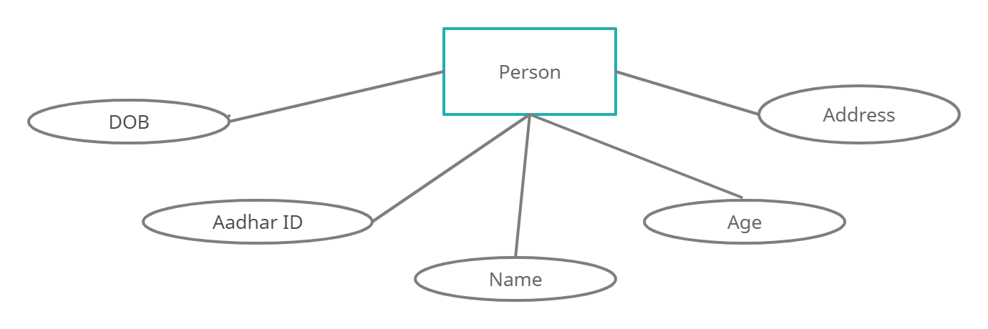
Objective:

The Objective of our mini project is to retrieve personal details from the files. When entered the Aadhar number, the program will display the personal details of the person.

Module Description:

We have connected a Database with the Python code. Here, functions such as insert, update, select and delete are used to modify and formulate the database for our personal information system.

We can insert a new data and update any of the details of a person. By selection function we can select one or many or all the data in the database.



CODE:
import mysql.connector
from tabulate import tabulate
con = mysql.connector.connect(host = "localhost", user = "root", password = "bhuvana", database = "PRO")
if(con):
print("Database Connection Successful")
mycursor = con.cursor()

def insert(pid,pname,age,dob,address):
res = con.cursor()
sql = "Insert into Person(PID,PNAME,AGE,DOB,ADDRESS) values(%s,%s,%s,%s,%s)"
person = (pid,pname,age,dob,address)
res.execute(sql,person)
con.commit()
print("Data Inserted Successfully")

def update(pid,pname,age,dob,address):
res = con.cursor()
sql = "Update Person set PNAME=%s,AGE=%s,DOB=%s,ADDRESS=%s where PID = %s"
per = (pname,age,dob,address,pid)
res.execute(sql,per)
con.commit()
print("Data Updated Successfully")

def select():
res = con.cursor()
sql = "Select PID,PNAME,AGE,DOB,ADDRESS from Person"
res.execute(sql)
result = res.fetchall()
print(tabulate(result,headers=["ID","NAME","AGE","DOB","ADDRESS"]))
def delete(pid):
res = con.cursor()
sql = "delete PNAME,AGE,DOB,ADDRESS from Person where pid = %s"
pers = (pname,age,dob,address,pid)
res.execute(sql,pers)
con.commit()
print("Data Deleted Successfully")

while (True):
print("*************************WELCOME TO PERSONAL DATA MANAGEMENT SYSTEM*************************")
print("1.Insert Data")
print("2.Update Data")
print("3.Select Data")
print("4.Delete Data")
print("5.Exit")
ch = int(input("Enter your choice: "))
if (ch == 1):
pid = int(input("Enter Aadhar ID: "))
pname = input("Enter Name: ")
age = int(input("Enter Age: "))
dob = input("Enter Date Of Birth: ")
address = input("Enter Address: ")
insert(pid,pname,age,dob,address)
elif (ch == 2):
pid = int(input("Enter Aadhar ID: "))
pname = input("Enter Name: ")
age = int(input("Enter Age: "))
dob = input("Enter Date Of Birth: ")
address = input("Enter Address: ")
update(pid,pname,age,dob,address)
elif (ch ==3):
select()
elif (ch == 4):
pid = int(input("Enter Aadhar ID you wish to delete: "))
delete(pid)
elif (ch ==5):
quit()
else:
print("Invalid Choice")

OUTPUT:
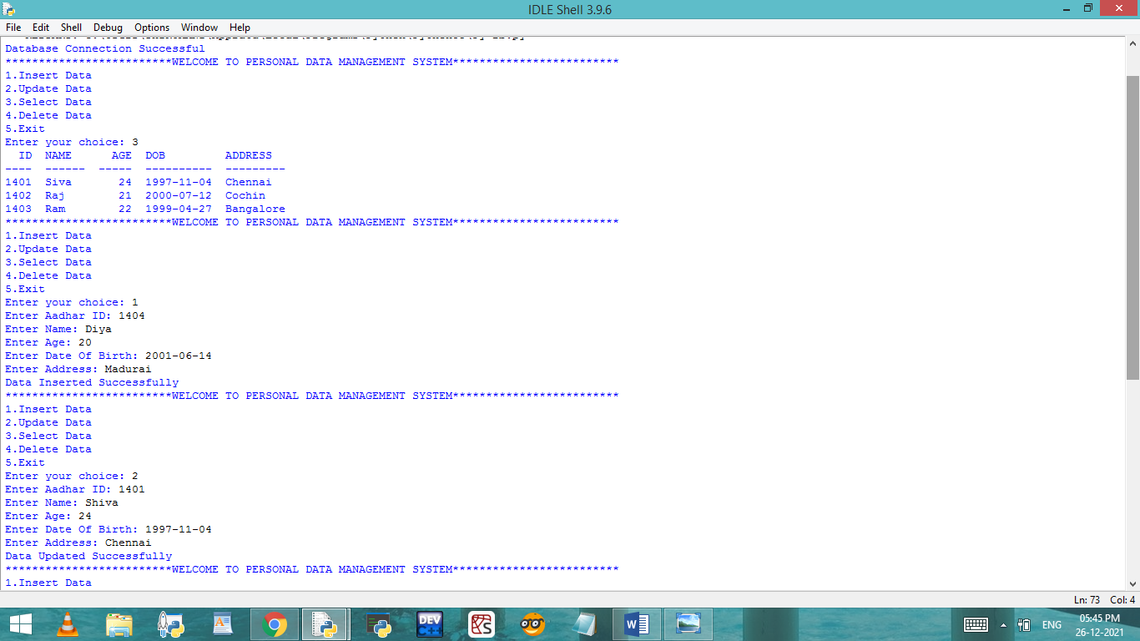

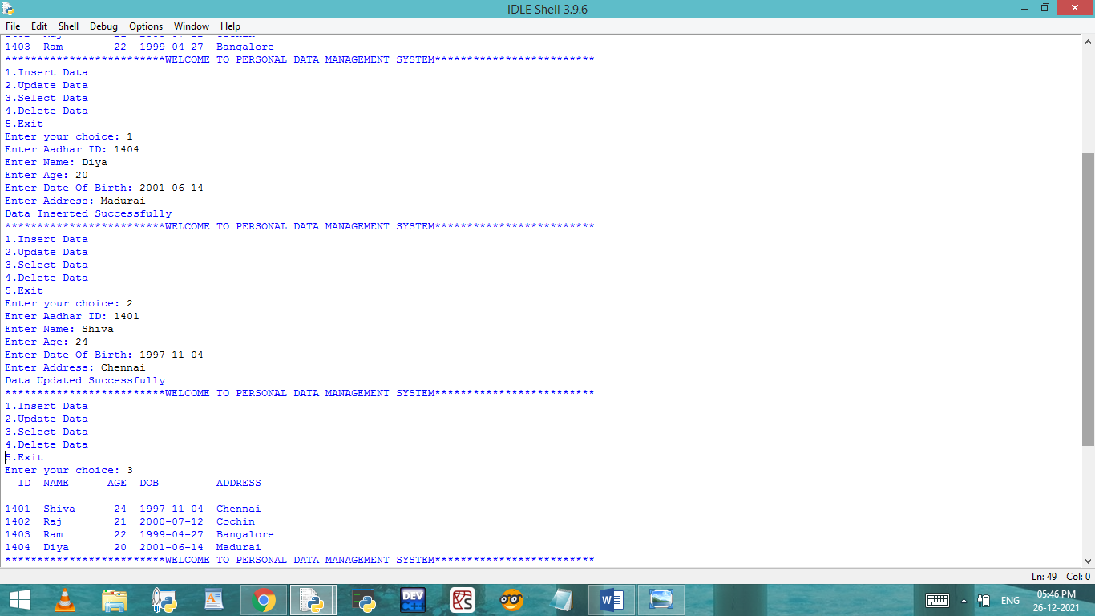
Conclusion:
Our mini project is to retrieve personal data from the database using python language. As a conclusion our main objective of retrieving data has been achieved successfully.
*******************************************************

